**Solution to Module 9 Problem 1**

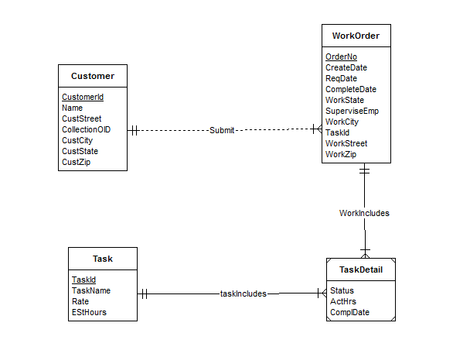

* The Customer, WorkOrder, Task entity types follow directly from the narrative. The narrative statement clearly indicates attributes and primary key for these entity types.
* The M-side of 1-M relationship, submit follows the narrative with customer has a collection of submitted work orders.
* The one side of the 1-M relationships is not specified in the narrative.
* The minimum cardinalities are not specified in the narrative so additional requirements collection is necessary.
* The difficult part of the narrative involves the relationship between WorkOrder and Tasks. The problem narrative indicates that a WorkOrder records a set of tasks and the same task can be performed on many work orders so an M-N relationship is necessary.
* The narrative states that each task on a work order has a status, actual hours, and a completion date. So the solution ERD uses an associative entity type (TaskDetail).
* More requirements collection is needed to determine the most appropriate solution.

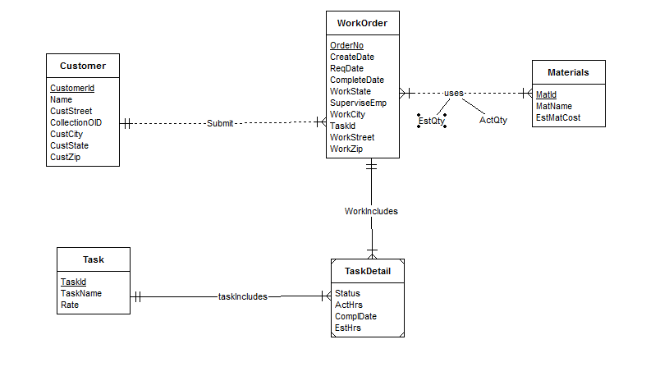

Transformations:

Add an entity Materials and relationship between Materials and WorkOrder.

Add attributes to the relationship Uses, EstQty and ActQty.

The attribute EstHrs is removed from Task entity and is added to Task Detail entity.

* The narrative states that a material can appear on multiple work orders and each work order uses a collection of materials so M-N relationship is required between the two entities. However, the minimum cardinality specifications are omitted.
* The narrative provides that the estimated number of hours for a task depends on the work order and task, not on the task alone so the change in the attribute is done.